11주차 실습

20135151 이갑성

1.

**import** java.util.*;

**public** **class** Quick {

**public** **static** **void** quickSort(**int**[] a)

{

*internalQuickSort*(a, 0, a.length-1);

}

**public** **static** **void** internalQuickSort(**int**[] a, **int** m, **int** n)

{

**int** p;

**if**(m > n){

**return**;

}

p = *partition*(a, m ,n);

*internalQuickSort*(a, m, p-1);

*internalQuickSort*(a, p+1, n);

}

**public** **static** **int** partition(**int** []a, **int** i, **int** j)

{

**int** pivot, p, temp, middle;

middle = (i+j) / 2;

pivot = a[middle];

a[middle] = a[i];

a[i] = pivot;

//pivot = a[i];

p = i;

**for**(**int** k = i + 1; k <= j; k++)

{

**if**(a[k] < pivot)

{

p = p + 1;

temp = a[p];

a[p] = a[k];

a[k] = temp;

}

}

temp = a[i];

a[i] = a[p];

a[p] = temp;

**return** p;

}

**public** **static** **void** main(String[] args) {

**int** a[] = **new** **int**[10];

Random r = **new** Random();

**for**(**int** i = 0; i < a.length; i++)

{

a[i] = r.nextInt(10);

}

System.***out***.println("========정렬전========");

**for**(**int** i = 0; i < a.length; i++)

{

System.***out***.print(a[i] + " ");

}

System.***out***.println("");

*quickSort*(a);

System.***out***.println("========정렬후========");

**for**(**int** i = 0; i < a.length; i++)

{

System.***out***.print(a[i] + " ");

}

System.***out***.println("");

}

}

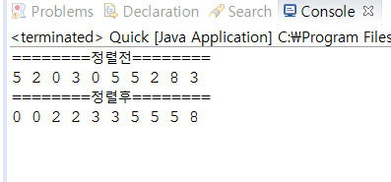

2.

5.

**import** java.util.*;

**public** **class** Merge {

**public** **static** **void** mergeSort(**int**[] a)

{

**int**[] temp = **new** **int**[a.length];

*internalMergeSort*(a, temp, 0, a.length-1);

}

**public** **static** **void** internalMergeSort(**int**[] a, **int**[] temp, **int** m, **int** n)

{

**if**(m < n)

{

**int** middle = (m+n) / 2;

*internalMergeSort*(a, temp, m, middle);

*internalMergeSort*(a, temp, middle+1, n);

*merge*(a, temp, m, middle, middle+1, n);

}

}

**public** **static** **void** merge(**int**[] a, **int**[] temp, **int** m, **int** p, **int** q, **int** n)

{

**int** t = m;

**int** numElements = n - m + 1;

**while**(m <= p && q <= n)

{

**if**(a[m] < a[q])

temp[t++] = a[m++];

**else**

temp[t++] = a[q++];

}

**while**(m <= p)

temp[t++] = a[m++];

**while**(q <= n)

temp[t++] = a[q++];

**for**(**int** i = 0; i < numElements; i++, n--)

a[n] = temp[n];

}

**public** **static** **void** main(String[] args) {

**int** a[] = **new** **int**[10];

Random r = **new** Random();

**for**(**int** i = 0; i < a.length; i++)

{

a[i] = r.nextInt(10);

}

System.***out***.println("========정렬전========");

**for**(**int** i = 0; i < a.length; i++)

{

System.***out***.print(a[i] + " ");

}

System.***out***.println("");

*mergeSort*(a);

System.***out***.println("========정렬후========");

**for**(**int** i = 0; i < a.length; i++)

{

System.***out***.print(a[i] + " ");

}

System.***out***.println("");

}

}

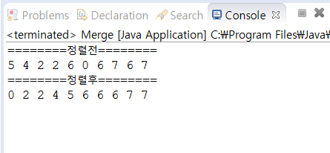

6번

**import** java.util.Random;

**public** **class** HeapSort {

**public** **static** **void** heapSort(**int**[] a)

{

**int** n = a.length - 1;

**for**(**int** i = n/2; i >= 1; i--)

*heapify*(a, i, n);

**for**(**int** i = n-1; i >= 1; i--)

{

**int** temp = a[1];

a[1] = a[i+1];

a[i+1] = temp;

*heapify*(a, 1, i);

}

}

**public** **static** **void** heapify(**int**[] a, **int** h, **int** m)

{

**int** j;

**int** root = a[h];

**for**(j = 2*h; j <= m; j = j * 2)

{

**if**(j < m)

**if**(a[j] < a[j+1])

j = j + 1;

**if**(root >= a[j])

**break**;

**else**

a[j/2] = a[j];

}

a[j/2] = root;

}

**public** **static** **void** main(String[] args) {

**int** a[] = **new** **int**[10];

Random r = **new** Random();

**for**(**int** i = 0; i < a.length; i++)

{

a[i] = r.nextInt(10);

}

System.***out***.println("========정렬전========");

**for**(**int** i = 0; i < a.length; i++)

{

System.***out***.print(a[i] + " ");

}

System.***out***.println("");

*heapSort*(a);

System.***out***.println("========정렬후========");

**for**(**int** i = 0; i < a.length; i++)

{

System.***out***.print(a[i] + " ");

}

System.***out***.println("");

}

}

